**Industrial Internship Report on**

**”URL Shortener”**

**Prepared by**

**G Murali**

|  |
| --- |
| *Executive Summary* |
| This report provides details of the Industrial Internship provided by upskill Campus and The IoT Academy in collaboration with Industrial Partner UniConverge Technologies Pvt Ltd (UCT).  This internship was focused on a project/problem statement provided by UCT. We had to finish the project including the report in 6 weeks’ time.  My project was The URL Shortener Project, implemented in Python, aims to simplify the process of sharing and accessing lengthy URLs. This project leverages Python's web development capabilities to create a user-friendly and efficient URL shortening service. By utilizing Python's backend programming, database management, and web frameworks, the project generates shortened URLs that redirect to the original webpages.  The Python-based URL shortener employs algorithms to generate unique and concise URLs, maintaining the functionality of the original links. It utilizes a database to store both the original and shortened URLs, enabling seamless retrieval and redirection. Python's robust libraries and frameworks facilitate the development of a secure and scalable system.  The user interface of the URL shortener is designed to be intuitive and user-friendly. Python's libraries, such as Flask or Django, can be utilized to create a web interface where users can input long URLs and generate shortened links efficiently. The generated URLs can be easily shared through various communication channels.  To ensure security, the Python-based URL shortener project implements measures to prevent unauthorized access, spamming, or abuse of the system. Python's built-in security features, as well as third-party libraries, can be employed to validate and sanitize user input and protect against common web vulnerabilities.  The project's use of Python also enables integration with analytics tools to track and analyze the performance of shared links. Python's data manipulation and analysis libraries, such as Pandas or NumPy, can be utilized to gather insights into user engagement, conversion rates, and other relevant metrics.  In summary, the Python-based URL Shortener Project provides a practical and efficient solution for managing and sharing lengthy URLs. By leveraging Python's web development capabilities, the project offers a secure, user-friendly, and scalable URL shortening service. It simplifies web navigation, enhances information sharing, and contributes to an improved online experience.  This internship gave me a very good opportunity to get exposure to Industrial problems and design/implement solution for that. It was an overall great experience to have this internship. |

**TABLE OF CONTENTS**

1 Preface 4

2 Introduction 8

2.1 About UniConverge Technologies Pvt Ltd 8

2.2 About upskill Campus 12

2.3 Objective 14

2.4 Reference 14

2.5 Glossary 15

3 Problem Statement 16

4 Existing and Proposed solution 17

5 My learnings 19

6 Future work scope 21

# Preface

**Summary of the whole 6 weeks’ work.**

At the first week I have gone through this e-book is designed as a comprehensive guide to help beginners learn Python programming. It covers the fundamental concepts of Python, including Functions, Strings, Web service, and object-oriented programming. The book also introduces you to essential libraries and packages commonly used in Python development. Optional chapters on data science provide a glimpse into the world of data manipulation, visualization, and machine learning with Python.

Throughout the book, code examples and exercises are provided to reinforce your understanding of the topics. The appendix includes a cheat sheet summarizing Python syntax and a glossary of commonly used terms for quick reference.

By the end of this e-book, I will have a solid foundation in Python programming and be ready to tackle more advanced topics or embark on my own Python projects.

After that I have gone through this e-book is designed as a comprehensive guide to help beginners learn Python programming. It covers the fundamental concepts of Python, including Functions, Strings, Web service, and object-oriented programming. The book also introduces you to essential libraries and packages commonly used in Python development. Optional chapters on data science provide a glimpse into the world of data manipulation, visualization, and machine learning with Python.

At the end of 5th week I have gone through this Numpy and its operations along with that Pandas and its Operations. It covers the fundamental concepts of Numpy and Pandas, including Functions in it like,

**NumPy functions, Pandas functions.**

**About need of relevant Internship in career development.**

A relevant internship plays a crucial role in career development by providing students or aspiring professionals with practical experience and exposure in their chosen field. It offers a unique opportunity to bridge the gap between academic learning and real-world application, allowing individuals to gain valuable skills, industry knowledge, and professional networks.

By participating in a relevant internship, individuals can:

Gain Hands-on Experience: Internships provide a platform to apply theoretical knowledge in practical scenarios, enabling individuals to develop a deeper understanding of their field. Through working on real projects and tasks, interns can acquire practical skills and learn how to navigate professional environments.

Explore Career Paths: Internships offer an opportunity to explore different career paths within a specific industry. By engaging with professionals and observing various roles and responsibilities, interns can gain insights into different career options and make informed decisions about their future trajectory.

Develop Professional Networks: Internships provide access to industry professionals who can serve as mentors, advisors, or potential future employers. Building meaningful connections during an internship can open doors to future job opportunities, references, and collaborations.

Enhance Communication and Soft Skills: Internships foster the development of essential soft skills such as communication, teamwork, problem-solving, and adaptability. These skills are highly valued by employers and contribute to overall professional growth and employability.

**Brief about Your project/problem statement.**

The project aims to address the challenges associated with lengthy and complex URLs by developing a URL shortening service. The goal is to create a system that generates concise and unique URLs, simplifying web navigation and improving the sharing and accessibility of web addresses. The project involves backend programming, database management, user interface design, and integration with analytics tools.

**How Program was planned**

The program was planned by outlining the project's objectives, scope, and deliverables. It involved conducting a thorough analysis of existing URL shortening techniques and technologies to determine the most suitable approach. The program also included defining the project timeline, allocating tasks, and identifying the required resources such as programming languages (Python), frameworks (Flask or Django), and databases (MySQL or PostgreSQL).

Additionally, the program incorporated regular progress evaluations, feedback sessions, and iterations to ensure the project's successful implementation. It also involved planning for user testing and integration with analytics tools to track the performance of the shortened URLs.

Overall, the program was designed to provide a structured framework for the development of the URL Shortener project, enabling efficient collaboration, skill acquisition, and a successful outcome.

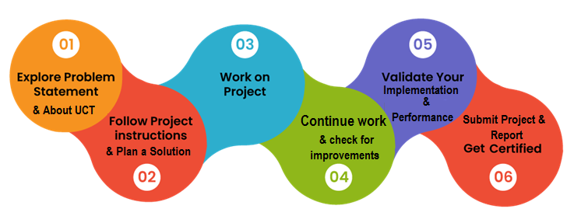

**Technical Skills**: Developing a URL shortener involves working with various technologies and programming languages, such as Python, web frameworks like Flask or Django, and databases like MySQL or PostgreSQL. You can gain hands-on experience in backend development, database management, API integration, and web application deployment.

**Algorithmic Thinking**: Designing an algorithm to generate unique and concise URLs requires problem-solving skills and algorithmic thinking. You may learn how to develop efficient algorithms that produce short URLs while ensuring uniqueness and avoiding collisions.

**Web Development**: Building a user-friendly web interface is an essential aspect of a URL shortener project. You can learn web development concepts, HTML, CSS, JavaScript, and front-end frameworks to create an intuitive and responsive user interface.

**Database Management**: Implementing a database to store original and shortened URLs involves understanding database concepts, designing schemas, and performing CRUD operations. You can learn how to interact with databases and handle data securely.

**Security Considerations**: URL shorteners may be susceptible to various security vulnerabilities, such as unauthorized access, spamming, or abuse. You can learn about web security best practices, such as input validation, sanitization, and protecting against common attacks like SQL injection or cross-site scripting (XSS).

**Analytics and Insights**: Integrating analytics tools allows you to gather insights into user engagement, conversion rates, and other metrics. You can learn how to track and analyze the performance of shared links, providing valuable data for decision-making and optimization.

**Collaboration and Project Management**: Working on a URL shortener project may involve collaborating with a team or stakeholders, managing timelines, and prioritizing tasks. You can gain experience in project management, communication, and teamwork.

Overall, developing a URL shortener project can provide a holistic learning experience, combining technical skills, problem-solving abilities, and exposure to web development best practices. It offers an opportunity to gain practical knowledge in areas relevant to web development, databases, security, and project management, all of which are valuable for future career prospects in software engineering or related fields.

Thank to the great that resources like Upskill Campus, W3Schools tutorials, and Python have been valuable in my learning journey. These platforms provide valuable knowledge and guidance for individuals seeking to enhance their skills in web development and programming with Python.

To our juniors,

I wanted to take a moment to share with you the incredible resource we have in Upskill Campus. It has been instrumental in expanding my knowledge and skills in various domains, including web development, programming, and more.

Upskill Campus offers a wide range of courses and tutorials, providing a structured learning path and practical hands-on exercises. The platform is designed to empower learners of all levels, from beginners to advanced students. The interactive nature of the courses allows you to actively engage with the material and apply what you learn in real-world scenarios.

Moreover, Upskill Campus provides a supportive community of learners and mentors who are always ready to assist and share their experiences. This collaborative environment fosters growth, encourages networking, and inspires you to push your boundaries.

I highly encourage you to explore the diverse courses and resources offered by Upskill Campus. Whether you are passionate about python, web development, data science, or any other field, there is something for everyone. Remember, continuous learning is key to staying ahead in our rapidly evolving industry, and Upskill Campus is an exceptional platform to help you do just that.

Embrace this opportunity, make the most of the resources available, and take your skills to new heights. Invest in your future by harnessing the power of Upskill Campus.

# Introduction

## About UniConverge Technologies Pvt Ltd

A company established in 2013 and working in Digital Transformation domain and providing Industrial solutions with prime focus on sustainability and RoI.

For developing its products and solutions it is leveraging various**Cutting Edge Technologies e.g. Internet of Things (IoT), Cyber Security, Cloud computing (AWS, Azure), Machine Learning, Communication Technologies (4G/5G/LoRaWAN), Java Full Stack, Python, Front end**etc.



1. UCT IoT Platform **(****)**

**UCT Insight** is an IOT platform designed for quick deployment of IOT applications on the same time providing valuable “insight” for your process/business. It has been built in Java for backend and ReactJS for Front end. It has support for MySQL and various NoSql Databases.

* It enables device connectivity via industry standard IoT protocols - MQTT, CoAP, HTTP, Modbus TCP, OPC UA
* It supports both cloud and on-premises deployments.

It has features to  
• Build Your own dashboard  
• Analytics and Reporting  
• Alert and Notification  
• Integration with third party application(Power BI, SAP, ERP)  
• Rule Engine

 

1. **Smart Factory Platform (****)**

Factory watch is a platform for smart factory needs.

It provides Users/ Factory

* with a scalable solution for their Production and asset monitoring
* OEE and predictive maintenance solution scaling up to digital twin for your assets.
* to unleased the true potential of the data that their machines are generating and helps to identify the KPIs and also improve them.
* A modular architecture that allows users to choose the service that they what to start and then can scale to more complex solutions as per their demands.

Its unique SaaS model helps users to save time, cost and money.

 

1. 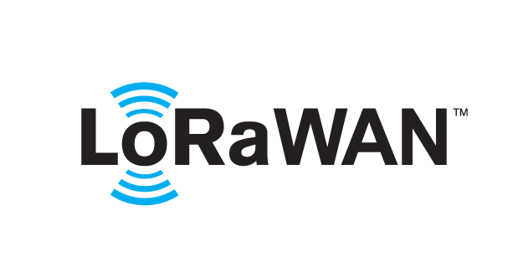 based Solution

UCT is one of the early adopters of LoRAWAN teschnology and providing solution in Agritech, Smart cities, Industrial Monitoring, Smart Street Light, Smart Water/ Gas/ Electricity metering solutions etc.

1. Predictive Maintenance

UCT is providing Industrial Machine health monitoring and Predictive maintenance solution leveraging Embedded system, Industrial IoT and Machine Learning Technologies by finding Remaining useful life time of various Machines used in production process.



## About upskill Campus (USC)

upskill Campus along with The IoT Academy and in association with Uniconverge technologies has facilitated the smooth execution of the complete internship process.

USC is a career development platform that delivers **personalized executive coaching** in a more affordable, scalable and measurable way.



Seeing need of upskilling in self paced manner along-with additional support services e.g. Internship, projects, interaction with Industry experts, Career growth Services

<https://www.upskillcampus.com/>

upSkill Campus aiming to upskill 1 million learners in next 5 year

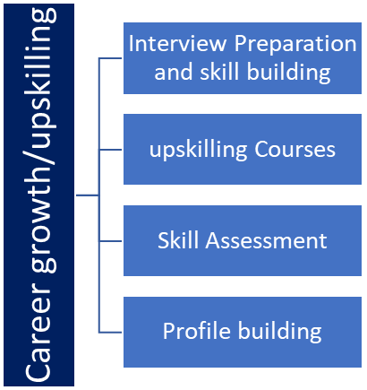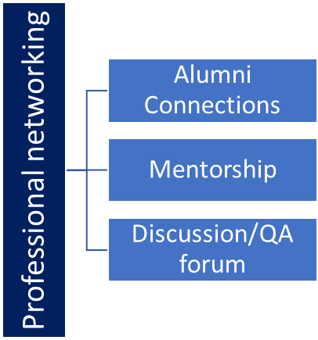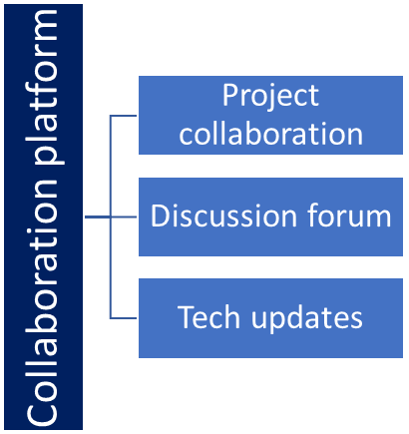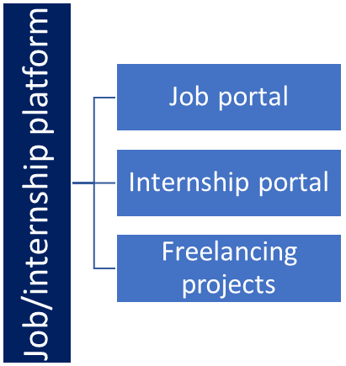

## The IoT Academy

The IoT academy is EdTech Division of UCT that is running long executive certification programs in collaboration with EICT Academy, IITK, IITR and IITG in multiple domains.

## Objectives of this Internship program

The objective for this internship program was to

 ☛ get practical experience of working in the industry.

 ☛ to solve real world problems.

 ☛ to have improved job prospects.

 ☛ to have Improved understanding of our field and its applications.

 ☛ to have Personal growth like better communication and problem solving.

## Reference

[1] GeeksforGeeks

[2] Javatpoint

[3] Python.org

[4] Real Python

## Glossary

|  |  |
| --- | --- |
| Terms | Acronym |
| URL | Uniform Resource Locator |
| Short URL | Shortened Uniform Resource Locator |
| API | Application Programming Interface |
| HTML | Hypertext Markup Language |
| CSS | Cascading Style Sheets |

# Problem Statement

In the assigned problem statement

The problem statement for the URL shortener project is to address the challenges posed by lengthy and complex URLs, and provide a solution that simplifies web navigation and improves the sharing and accessibility of web addresses. The goal is to develop a system that generates short, unique, and user-friendly URLs, while preserving the functionality of the original URLs.

The key issues to be addressed in the problem statement include:

**Lengthy URLs**: With the growth of online content, URLs have become longer and more complex, making it inconvenient and error-prone to manually enter or share them.

**User-Friendly Sharing**: Users often encounter difficulty sharing long URLs through communication channels with character limitations, such as social media platforms, messaging apps, or email.

**Aesthetic Considerations**: Lengthy URLs can negatively impact the visual appeal of web content, especially in cases where concise presentation is essential, such as social media posts or limited character platforms.

**Tracking and Analytics**: Marketers, businesses, and content creators often require analytics to track the performance of shared URLs, including click-through rates, user engagement, and conversion rates.

# Existing and Proposed solution

**My proposed solution**

The solution should include the following features:

**URL Shortening**: The system should generate unique and concise shortened URLs based on the original long URLs, ensuring the redirection to the correct destination.

**User Interface**: A user-friendly web interface should be provided, allowing users to input long URLs and quickly obtain the corresponding shortened URLs.

**Redirection**: The system should seamlessly redirect users from the shortened URL to the original webpage without any loss of functionality or content.

**Security Measures**: The URL shortener should incorporate measures to prevent unauthorized access, spamming, or abuse of the system.

**Analytics Integration**: The system should integrate with analytics tools to track and analyze the performance of the shared links, providing valuable insights into user engagement and conversion rates.

The successful implementation of the URL shortener project will result in a reliable, user-friendly, and efficient solution that simplifies web navigation, enhances information sharing, and contributes to an improved online experience.

**The value addition of my planning:**

**Customizable URLs**: Allow users to customize their shortened URLs with meaningful or personalized keywords. This feature adds a personal touch and can make the links more memorable and recognizable.

**Link Expiration**: Implement an option to set an expiration date for the shortened URLs. This feature can be useful for time-limited promotions or temporary content, ensuring that the links automatically expire and no longer redirect after a specified period.

**Link Analytics and Reporting**: Provide comprehensive analytics and reporting capabilities to track the performance of shortened URLs. This could include metrics such as click-through rates, geographical distribution of clicks, referral sources, and other relevant data. Presenting these analytics in an intuitive and visually appealing dashboard can offer valuable insights to users.

**Link Management**: Develop a user-friendly dashboard or interface that allows users to manage and organize their shortened URLs. This could include features such as categorization, tags, search functionality, and the ability to edit or delete existing links.

**Social Media Integration:** Enable easy sharing of shortened URLs on popular social media platforms. This could involve integrating with social media APIs, allowing users to directly share their shortened links to their social media accounts or schedule automatic sharing.

**Link Preview**: Provide a preview functionality that displays a snippet or preview of the target webpage when users hover over a shortened URL. This can help users get a glimpse of the content they will be redirected to before clicking on the link.

**API Access:** Offer an API (Application Programming Interface) that allows developers to integrate the URL shortener service into their own applications or websites. This enables seamless integration of the shortening service into existing workflows or platforms.

These value additions can enhance the functionality, usability, and user experience of a URL shortener project, providing additional features and benefits to both individual users and businesses. The specific value additions chosen will depend on the project's goals, target audience, and the available resources.

## Code submission (<https://github.com/gmurali03/Upskill-Campus>)

## Report submission (<https://github.com/gmurali03/Upskill-Campus>) :

# My learnings

**Summary of Overall Learning and Career Growth:**

Throughout the internship project on URL shortener, I gained valuable knowledge and experience in various aspects of web development, Python programming, database management, and security considerations. Here is a summary of my overall learning and how it would contribute to my career growth.

Technical Skills: I developed proficiency in Python programming and its libraries, specifically in the context of web development using frameworks like Flask or Django. I gained hands-on experience in backend development, database management (MySQL or PostgreSQL), and API integration. These skills are highly sought after in the industry and will be valuable for future career opportunities.

Algorithmic Thinking: Designing the algorithm for generating unique and concise URLs required problem-solving skills and algorithmic thinking. I learned how to develop efficient algorithms that ensure uniqueness while avoiding collisions. This skill is transferable to other projects and problem-solving scenarios.

Web Development: I acquired knowledge of web development concepts, including HTML, CSS, and JavaScript, which allowed me to create a user-friendly and visually appealing user interface for the URL shortener project. This understanding of web development principles will be beneficial in future projects involving frontend development.

Database Management: Implementing a database to store the original and shortened URLs provided insight into database concepts, schema design, and CRUD operations. This knowledge can be applied to other projects that require database management and data manipulation.

Security Considerations: The project's focus on implementing security measures against unauthorized access, spamming, and abuse enhanced my understanding of web security best practices. I learned about input validation, sanitization, and protection against common attacks like SQL injection and cross-site scripting (XSS). This knowledge will be valuable in ensuring the security of future web applications.

Collaboration and Project Management: Working on the URL shortener project provided exposure to collaboration with team members and stakeholders. I learned to manage timelines, prioritize tasks, and communicate effectively. These project management and teamwork skills will be beneficial in any future collaborative projects.

Analytical Skills: Integrating analytics tools to track and analyze the performance of shared links expanded my knowledge of data analysis and insights. I gained experience in gathering and interpreting metrics such as click-through rates and user engagement. These skills are crucial in understanding user behavior and optimizing web applications.

Overall, the internship project on the URL shortener provided me with a comprehensive learning experience in web development, Python programming, database management, security considerations, and project management. These skills and knowledge will contribute significantly to my career growth in the field of software engineering or related areas. I am confident that the practical experience gained during this internship will enhance my job prospects and equip me to tackle future projects and challenges successfully.

# Future work scope

While working on the URL shortener project, there were certain ideas and features that could not be implemented due to time limitations. However, these ideas hold potential and can be explored as future enhancements. Some of the future work scope for the URL shortener project includes:

**User Account Management**: Implementing user accounts and authentication mechanisms can provide personalized experiences to users. It can enable features such as URL history, link management, and customized analytics for each user.

Link Expiry Notifications: Adding automated notifications to inform users when their shortened links are about to expire or have expired can enhance user experience and prevent broken links.

**Customizable Link Preview**: Enhancing the link preview feature to provide more detailed information about the target webpage, including metadata, thumbnail images, and a brief description. This can further improve user engagement and decision-making when clicking on shortened links.

QR Code Generation: Integrating QR code generation functionality, allowing users to generate QR codes for their shortened URLs. QR codes are increasingly used for easy sharing and scanning, particularly in mobile applications.

**Integration with Social Media APIs**: Enabling seamless integration with popular social media platforms' APIs can simplify the process of sharing shortened URLs directly to social media accounts. It can also provide additional analytics and insights into social media engagement.

These are just a few ideas for future enhancements to the URL shortener project. Depending on the project's requirements, target audience, and available resources, additional features and improvements can be explored to further enhance the functionality, usability, and user experience of the URL shortener system.